Daily intake tests

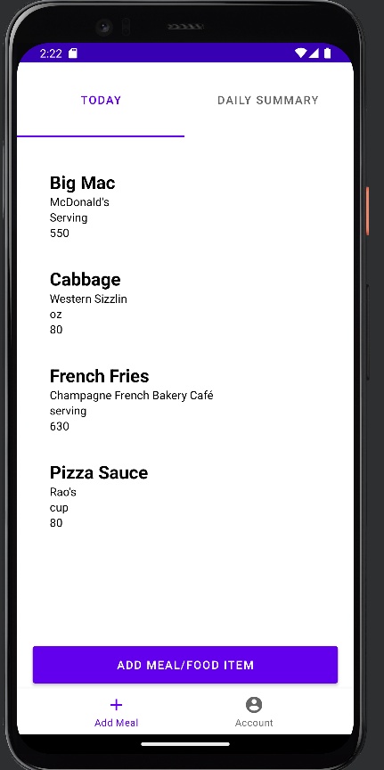
- Add meals to diary and check calculation are correct

Meals added total calories should be 550+80+630+80 = 1340

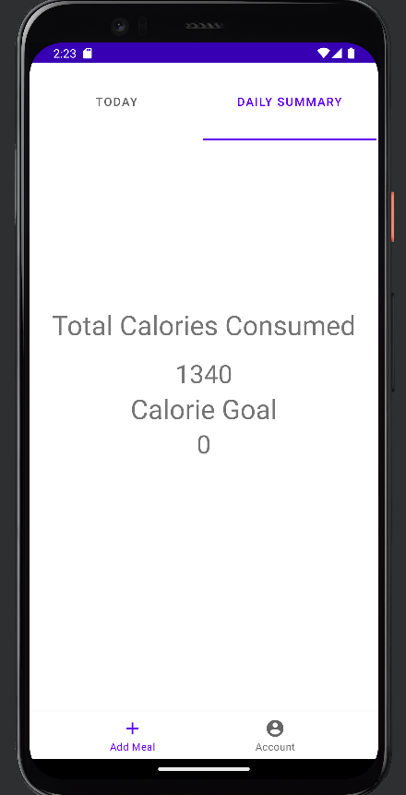

Total calories are correct TEST PASSED

- Remove meal and ensure it total calories updates
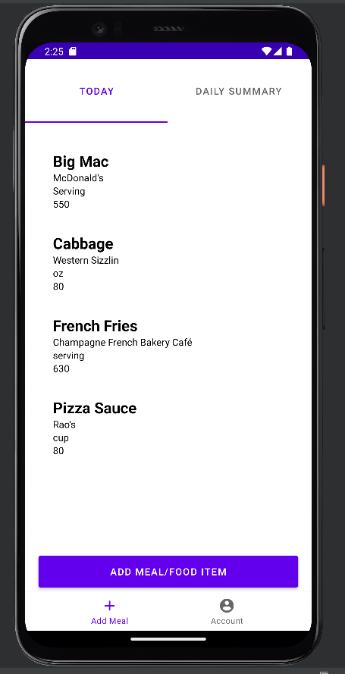

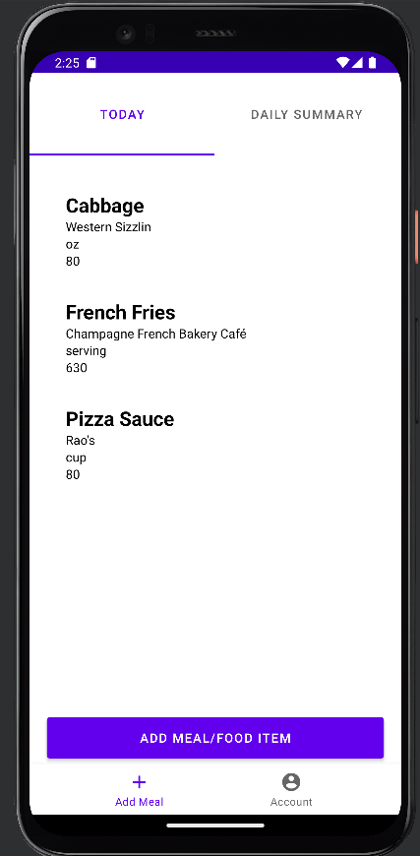
Item to be removed

Item removed total calories should be 1340-550 = 790
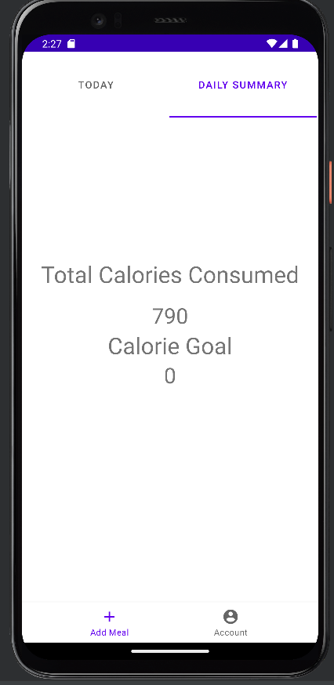

Total calories consumed is correct TEST PASSED

- Kill application and return to daily summary page to ensure total calories are saved
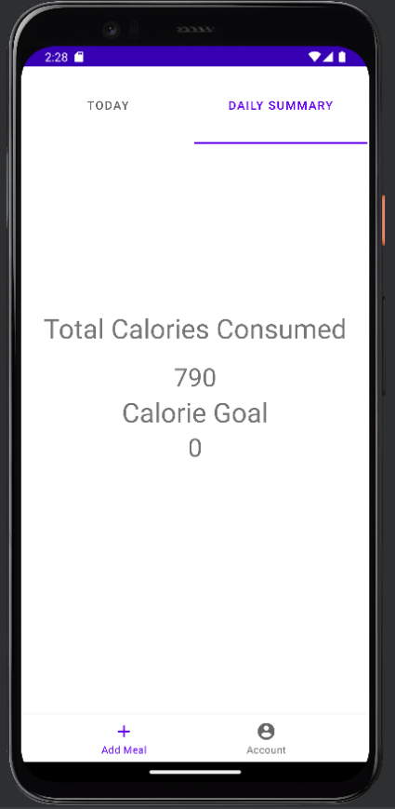

Before killing application value is 790

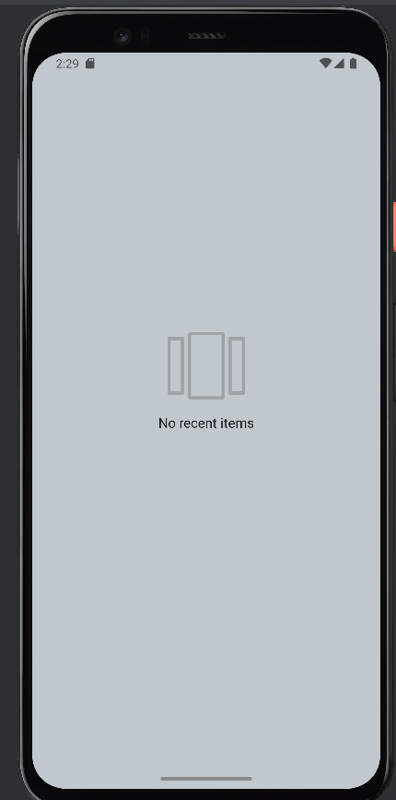

Application killed

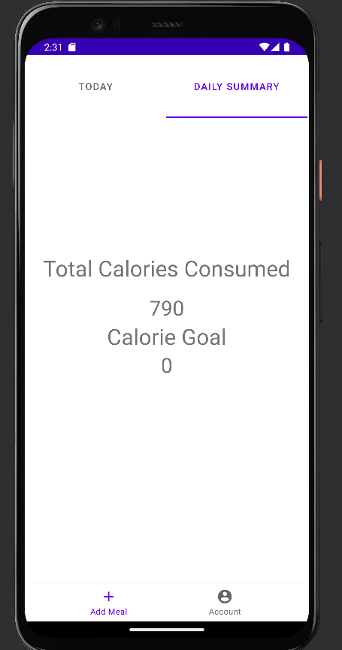

Returned to application value is still 790 TEST PASSED

